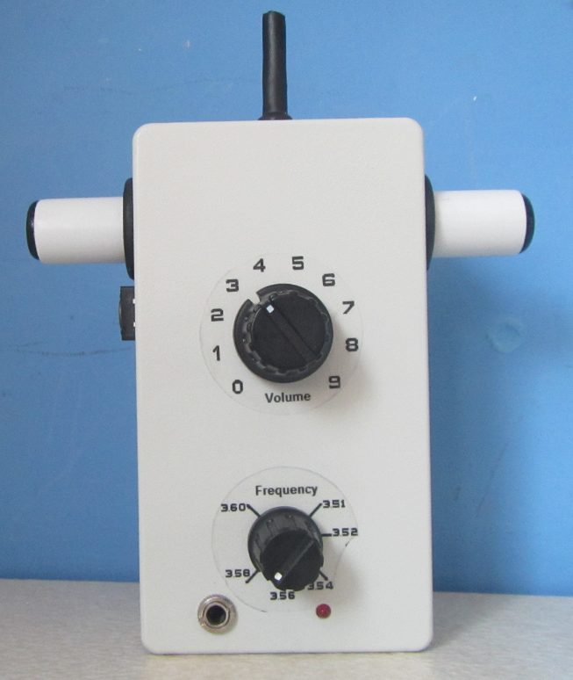

**ARDF RECEIVER ROX80-VT3A**

**By G3ZOI**

**(with Kit Building notes by G4ARI)**

**Introduction**

The ROX80-VT3A is a small 80 metre direct conversion receiver designed by David Dean, G3ZOI, to be used in the classic (International) type ARDF events. These are pedestrian ARDF events where the distance from a 1 to 3 watt transmitter is not likely to be greater than 3 km. However, the receiver is sensitive enough to monitor more distant transmissions where propagation conditions are favourable. It is also a very handy tool for DFing local 80 metre interference.

The VXO uses a 3.580MHz ceramic resonator which is pulled to give a stable tuning range from 3.510 MHz to 3.600 MHz.

**Specifications**

Power Supply: 9 volts from a PP3 battery

Target Frequency: 3.510 MHz to 3.600 MHz

Current consumption: 16mA

Sensitivity: Better than 1uV (-107 dBm), typically -118.5dBm for 3dB Signal to Noise ratio.

Sense front to back ratio: Up to 17 dB with short ant or internal wire only.

**Building Tip**

Find a small block of wood, similar in size to the enclosure and drill two 6mm diameter holes at least 10mm deep, 44mm apart. The PCB with pots fitted allows the shafts placed in the holes and helps with testing and assembling the board.

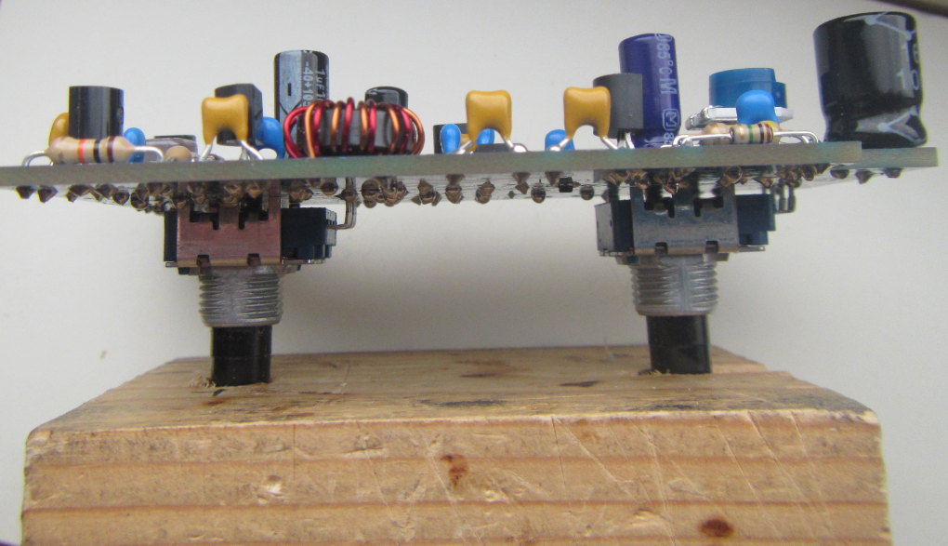

**Populating the PCB**

All the holes are through plated. Avoid misplacing components or filling in the solder holes accidentally as these are not easy to de-solder.

**Resistors**

Lead-outs should be bent for 10mm hole spacing.

**Capacitors**

All are 5mm lead-out spacing.

Electrolytic capacitors – the negative lead shown on the PCB shaded

C18 100uF should be bipolar, looks like an electrolytic but is a non-polarised type.

**Inductors**

L1 which is 2 x 10 turns is best wound with two different coloured enamel wire to be able to distinguish each winding

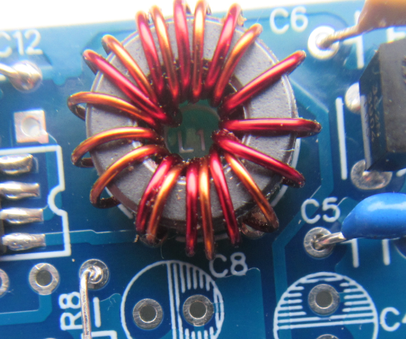

L2 should be wound with the thinner enamel wire.

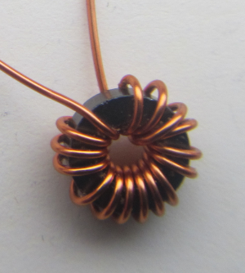

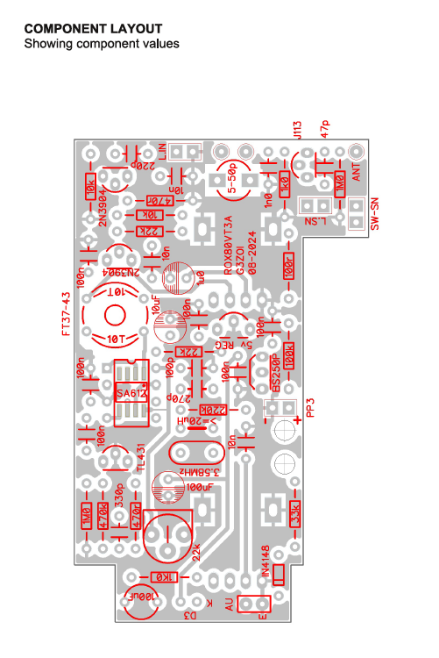

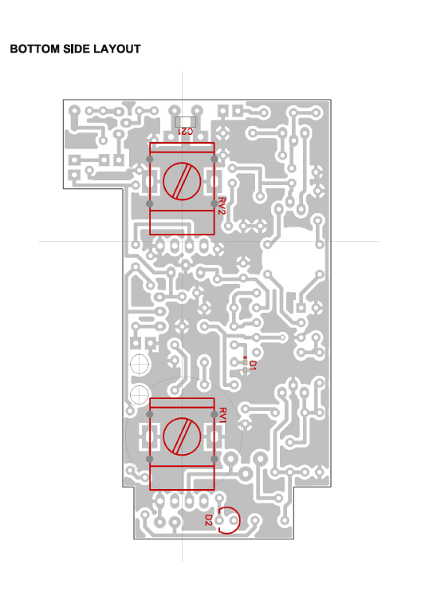

**Tuning Range**

The target tuning range is 3.510 MHz to 3.600 MHz which is the IARU defined band.

Pulling the frequency (tuning the receiver) is achieved using the capacitance from a varicap diode which is already soldered on to the back of the PCB, marked as **D1**.

**Series Inductor L2**

This is wound on to the smaller ferrite ring (type FT23-43) with **14 turns**

**Tuning Range Set-up**

Connect the PP3 battery and monitor the VXO output on a receiver.

Turn the tuning control fully anticlockwise. The frequency should be about 3.510 MHz.

Turn the tuning control fully clockwise and adjust RT1 until the VXO signal can be heard on a receiver close to 3.600 MHz.

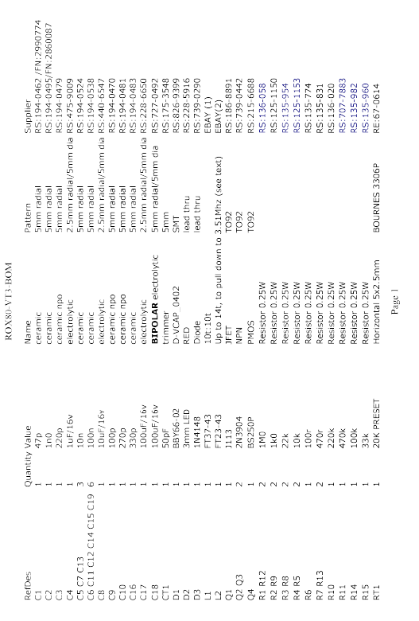

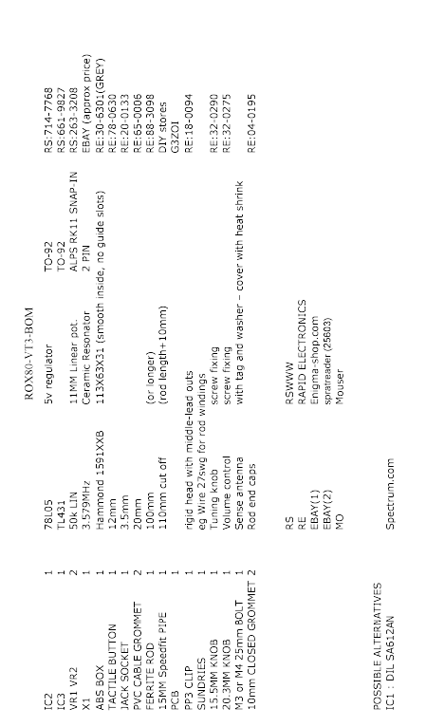

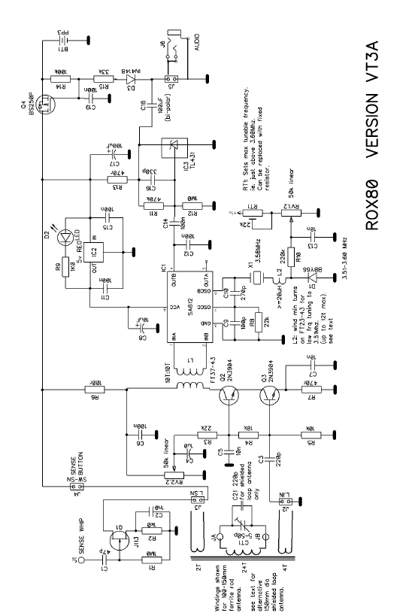

**Building the Ferrite Rod Antenna**

Parts List

100mm x 10mm ferrite rod

Plastic tube 15mm diameter, which should be 10mm longer than the ferrite rod.

2 x 20mm grommets

2 x 10mm closed grommets for the ends of the plastic tube

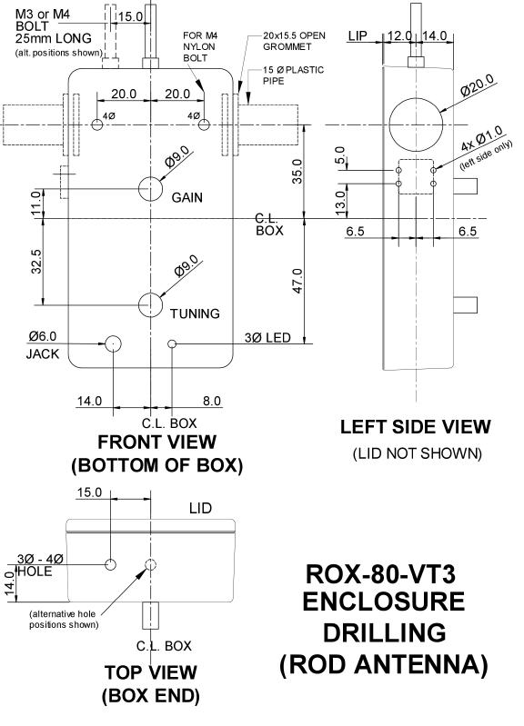

**Box Preparation**

For the best accuracy, measure from the centre of the box.

Snip off the 4 stand-offs from inside the box and the lid.

Drilling the holes is straight forward except as follows -:

* The positioning of the 2 large 20mm holes is CRITICAL, check before you drill.
* The two opposite holes must be accurately aligned.
* **Mark out the 20mm hole circles, not just the hole centre**.

The recommended method for drilling the 20mm holes is to used a stepped drill bit.

Check the drill hole as the drill size increases against the marked hole outline.

If the hole drifts off-centre, stop drilling and correct using a file or reamer before continuing.

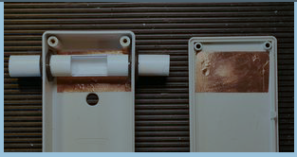

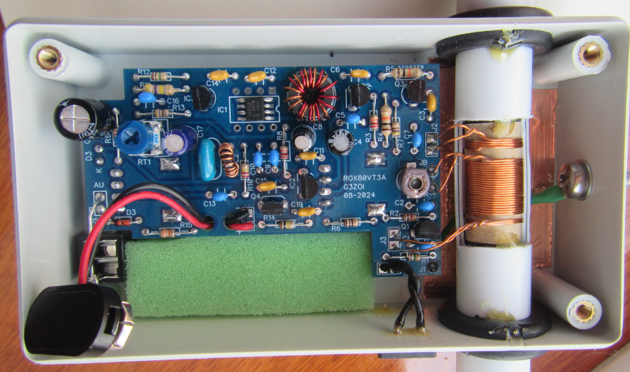

**Antenna Rod Housing**

A video of the building of the Rod Antenna can be found on YouTube <https://www.youtube.com/watch?v=okiGt-biyyQ>. At the start of the video David Dean refers to the number of turns on the main coil as being 22 turns, however this has been changed to 24 turns.

It’s very important to wind all the coils in the same direction.

After the coils have been wound, while the former is on the ferrite rod, carefully treat the top of the coil windings with two coats of UPVA glue, a thin coat, then a thicker coat, which will hold the windings in place and stiffen up the coil former. Only apply a small amount UPVA, ideally done with a cotton bud.

The End Caps, are made from the supplied 10mm closed grommets and cut as shown below



The twisted leadouts should be cut to the following lengths -:

Input - shown on the left – 10mm

Main - the large coil in the middle – 15mm

Sense – the two-turn winding on the right – 25mm

Where the Sense windings connect to J3, these connections might need to be reversed after testing, shown below circled in **RED**

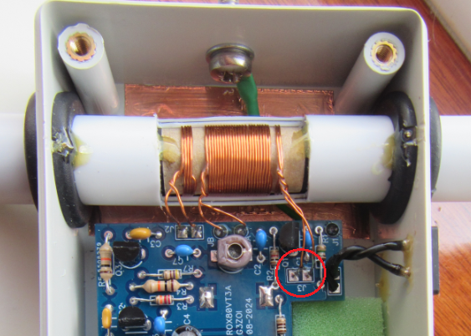

**Sense Antenna**

The wire connecting J1 on the PCB to the Sense antenna, forms part of the Sense antenna so ideally should be vertical, and best routed underneath the rod antenna.

The Sense antenna is made from the supplied 25mm bolt with the solder tag on the inside of the enclosure, so will have to be located before the rod antenna and tube are assembled and fitted to the case.

The thread of the Sense antenna can be covered with heat shrink tubing.

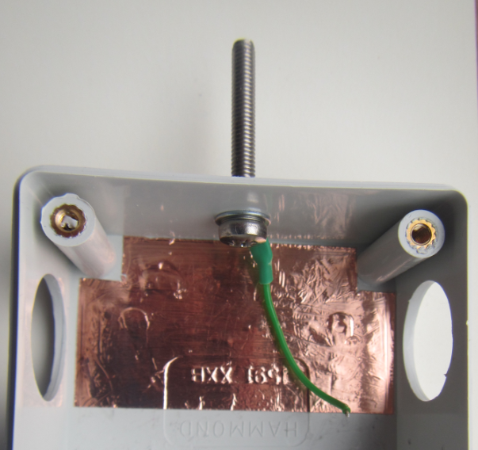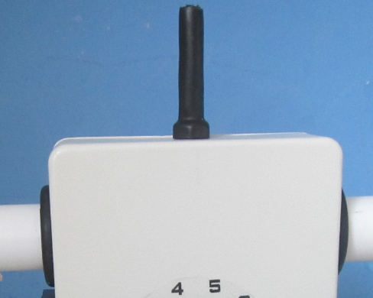

**Labelling the Case**

It is suggested that you mark the frequency of the commonly used UK ARDF frequency, 3.58 MHz, and it may be helpful to mark the volume control with numbers. Alternatively print out the graphics below and stick them to the receiver.

